

DEBRE TABOR UNIVERSITY

**FACULITY OF TECHNOLOGY**

**DEPARTMENT OF COMPUTER SCIENCE**

**ሰሰ**

**FINAL PROJECT ON**

**HIBRET HOTEL ONLINE CINEMA TICKET RESERVATION SYSTEM**

**FINAL PROJECT SUBMITTED TO THE FACULTY OF TECHNOLOGY DEPARTMENT OF COMPUTER SCIENCE OF DEBRETABOR UNIVERSITY IN PARTIAL FULFILMENT OF THE REQUIREMENTS FOR THE DEGREE OF BSC IN COMPUTER SCIENCE**

**BY:**

NAME **ID**

1, AMELEWERK DEBAS------------------------------------------------------------2211/06

2, ANDNET TEKA---------------------------------------------------------------------2213/06

3, MANAMNO MIHRET-------------------------------------------------------------2269/06

4, MENGESHA MOLAWORK------------------------------------------------------2326/06

5, MEQUANT BOGALE--------------------------------------------------------------2274/06

6, YISHAK YIFERU-------------------------------------------------------------------2315/06

**ADVISOR:**

**Mr. Sissay Yemata June 17/10/2009 E.C**

**Acknowledgement**

**First we like to thank our advisor Mr. Sissay Yemata for his excellent advice and active guidance throughout this project. Thanks to our friends whose support and encouragement goes even beyond the accomplishment of this project.**

**Secondly we like to thanks for all computer science department instructors and department of information technology.**

**Finally we like to thank Debre Tabor University and Hibret Hotel cinema manager and the cinema and employees who works in the cinema gave us necessary information.**

**Abstract**

**On line Hibret Hotel cinema ticket reservation is one of the basic activities of ticket reservation system. Currently in Debre Tabor town, the Hibret Hotel cinema ticket reservation system is used now manually. Because of this manual system there are so many difficulties on its progress in terms of effectiveness. Some of those difficulties are customer cannot reserve ticket on line before going to the place of the cinema, cannot accesses cinema movies schedule and cinema movies schedule do not advertise easy, time consuming .So the project we are going to develop would try to recommend those problems and providing prototype of the system. Because the system to be developed is online, it includes online reservation ticket and online payment system.**

# 

Table of Contents page

**CHAPTER ONE: INTRODUCTION** 1

**1.1 Background of the Organization** 2

**1.2 The Existing system study** 2

**1.3 Statements of the problem** 2

**1.4 Feasibility Study** 3

**1.4.1 Technical Feasibility** 3

**1.4.2 Economic Feasibility** 3

**1.4.3 Operational Feasibility** 4

**1.4.4 Political feasibility** 5

**1.4.5 Schedule feasibility** 5

**1.5 Project objective** 5

**1.5.1 General objective of the system** 5

**1.5.2 Specific Objectives of the system** 5

**1.6 Scope of the project** 6

**1.7 Significance of project** 6

**1.8 Methodology** 7

**1.8.1 Data gathering method** 7

**1.8.2 Design methodology** 8

**1.8.3 Implementation** 8

**1.8.4. Testing methodology** 9

**Integration Testing** 9

**Alpha testing** 10

**Beta testing** 10

**CHAPTER TWO: REQUIRMENT ANALYSIS DESCRIPTION** 11

**2.1 Overview of existing system** 11

**2.1.1 Activities of the existing system** 11

**2.1.2 Problems in the existing system** 12

**2.1.3 Weakness and Strength** 13

**2.2 Overview of the proposed system** 13

**2.2.1 Functional requirement** 14

**2.2.2 Non Functional Requirements** 14

**2.2.3 System Requirement** 15

**2.2.4 User Requirement** 15

**2.2.5 Business Rules in the Existing System** 16

**CHAPTER THREE: SYSTEM MODELING** 17

**3.1 use case model** 17

**3.1.1 Actor specification** 17

**3.1.2 Use case description** 19

**3.2 Sequence Diagram** 30

**3.3 class diagram** 35

**3.4 Activity Diagram** 36

**CHAPTER FOUR: SYSTEM DESIGN** 42

**4.1 Design Goal** 42

**4.2 System Decomposition** 42

**4.3 System architecture design** 43

**4.4 Deployment Diagram** 44

**4.5 Persistence Data Management** 46

**4.6 Access control and security** 46

**4.7 User Interface Design** 48

**CHAPTER FIVE: IMPLEMENTATION** 51

**5.2 Algorithm** 52

**5.3 Environments** 53

**5.4 Sample code and sample output sample code of advert** 53

**CHAPTER SIX: TESTING** 71

**6.1 Unit testing** 71

**6.2 Integration Testing** 71

**6.3 System testing** 71

**6.3.1 Alpha testing** 72

**6.3.2 Beta testing** 72

**CHAPTER SEVEN: CONCLUSION AND RECOMMENDATION** 73

**7.1 Conclusion** 73

**7.2 Recommendation** 73

**Appendix** 75

**LIST OF TABLE PAGE**

**Table 1:1 schedule feasibility** 5

**Table 3:1 actor specification** 17

**Table 3:2 use case description for register** 19

**Table 3:3 Login** 20

**Table 3:4 Upload announcement** 21

**Table 3:5 Update announcement movie** 22

**Table 3:6 Add movie schedule** 23

**Table 3:7 View seat information** 24

**Table 3:8 Reserve** 25

**Table 3:9 delete movie schedule** 26

**Table 3:10 Update account** 27

**Table 3:11 View Feed back** 28

**Table 3:12 Logout** 29

**Table 3:13 Payment** 29

**Table 4:1 access control and security** 47

**List of figure**  **page**

**Figure 2:1 Activity of existing system……………………………………………………………………………………………….12**

**Figure 3:1 Use case diagram…………………………………………………………………………………………………………….18**

**Figure 3: 2 Login sequence diagram……………………………………..………………………………………………………….30**

**Figure 3:3 Register sequence diagram……………………………………………….…………………………………………….30**

**Figure 3:4 reserve ticket sequence diagram……………………………………….…………………………………………….31**

**Figure 3:5view seat information sequence diagram……..…………………….……………………………………………31**

**Figure 3:6 add movie schedule sequence diagram…………………………….………………………………………………32**

**Figure 3:7advertise movie sequence diagram……………………………………………………………………….……….…32**

**Figure 3:8 add news sequence diagram…………………………..…………….…………………………………………..….…33**

**Figure 3:9 manage add movie sequence diagram……………..…………….…………………………………………..33**

**Figure 3:10 delete movie schedule sequence diagram………………………………………………………………….34**

**Figure 3:11 upload announcement sequence diagram…………………….……………………………………….…..34**

**Figure 3:12 give feedback sequence diagram………………………………….…………………………………………….35**

**Figure 3:13 class diagram………………..…………………………………………….…………………………………..…………36**

**Figure 3:14 register activity diagram diagram………………………………….……………………………….…………..37**

**Figure 3:15 login activity diagram…………………………………………………….………………………………….….……38**

**Figure 3:16 reserve ticket activity diagram………………..……………………….………………………………….…..…39**

**Figure 3:17 view seat information activity diagram………………..……………………………………….…………….40**

**Figure 3:18 advert movie activity activity diagram………………..……….….….………………………………………41**

**Figure 4:1 system decomposition diagram………………..……………………….……………….…………………………43**

**Figure 4:2 architectural diagram………………..……………………….………………………………….…………..………44**

**Figure 4:3 deployment diagram……………..……………………….……………………………..…………………………….45**

**Figure 4:4 Persistent data management diagram………….………………….…………………………………….…….46**

**Figure 4:5 home page interface diagram………………..……………………….………………………………..….………48**

**Figure 4:6 Registration system diagram………………..……………………….…………………………………..…………49**

**Figure 4:7 login form diagram……………………………….……………………….……………………………….……….…..50**

**Figure 5:1 Sample output of home page………………..……………………….……………………………….………..….68**

**Figure 5:2 sample output of login………. ………………..……………………….……………………………….……………69**

**Figure 5:3 sample output of registration………. ………………..……………………….……………………………….…70**

**Acronyms**

HTTP-hypertext transfer protocol

BR-business rule

DB-data base

URL-uniform resource locator

SQL-structured query language

DBMS-data base management system

HTML-hypertext markup language

CSS-cascading style sheet

MTD-Movie Ticket Dispenser

UC –use case

**Symbol**

Symbol Definition

 Actor

 Use case



Package

 Component

 Node

 System boundary

 Message return

 Dependency

 Line connector

 Message

# 

# **CHAPTER ONE****: INTRODUCTION**

The entertainment industry is one of the most profitable sectors in the business world. People always spent money for being entertained, and so they in the future. The only problem is how people get to know about all the currently presented movies as well as the future ones, and then, in case they know, how they can get tickets. This problem used to be solved by theaters’ ticket kiosks at the Showtime or by phone reservation which are in most cases restricted by time, location, and most important by availability of tickets. Because of that reason our document would describe the implementation details of a Movie Ticket Dispenser (MTD). The system would allow the user to buy tickets online for movies that are either available in the system’s own database or available using web services offered by the Entertainment companies, but accessed by the MTD. Bookings can be made independent of time and location.

Hibret hotel Cinema ticket reservation system aims to provide suitable environment and helpful cinema to customers on how to make bookings and reservation for cinema and to minimize the hassle of travelling down to the cinema location before making reservations and queuing up for tickets to avoid congestions. This involves making the customer aware of seat reservation schemes. Cinema Ticket booking system achieves this using cinema booking software, which would contain various events that result into a graphical interface booking system which even special people can make reservations. This project makes it easy to make reservations for users to watch a movie at would anytime they want and anywhere they choose as long as they are connected to the Internet instead of travelling down to the booking center and this is time wasting. Being an online booking system, it would assist managers and administrators to update movie information that can be accessed by customers, help confirm reservations and educate the customers on how to book cinema ticket, and seat reservation online in such a way that the congestion involved be reduced. Online cinema ticket booking system is needed in order to run a check on the authenticity of the tickets to avoid fraud manipulated booking.

## **1.1 Background of the Organization**

Hibret Hotel cinema is the first private cinema in Debre Tabor .It was established on May 2005 E.C. and managed by the owner of Hibret Hotel who has a great role on the cinema.

The Cinema has 1500 seats and 7 employees including the manager. It has large hall and non-organized staff and also it has high screen quality (4*3) resolution, three sound buffer (like mixer) and twelve small speakers in the wall. Every customer pays 30 birr for each movie. It tries to give enjoy full and very comfortable services for the customers in addition to the hotel service.

## **1.2 The Existing system study**

The current system of Hibret Hotel cinemais entirely manual where staff at the ticket box processes everything without the aid of any technology. They give tickets to the customers manually and the movie is promoted by vehicle and posting posters of the movie all over Debre Tabor town main places. To watch a single movie the customer is expected to buy a ticket and have to go earlier to have a good spot.

Generally the current system is overwhelming, time and cost consuming process as well as tedious to the staffs.

## **1.3 Statements of the problem**

We are investigating problems in the current system that occur in Hibret Hotel Cinema:-

* The absence of online ticket reservation system and advertisement. The existing system gets all of its work done manually and this cannot create safe environment for the customers. This system results a crowd and Wastage of resource utilization. The private limited company wants to advertise in order to address the customer and increase usability of the service .*B*ut in Hibret Hotel cinema announcing of the movies list to customer is the big problem. Currently the advertisement is done by posting the advertisement in different place especially in concourse, circulating the town by car by using advertiser and generator as well as megaphone .This type advertisement technique is very tedious and less profitable.
* There are a number of employee in the cinema hall and they needs payment for their work .This leads less profitable for the cinema owner.

## **1.4 Feasibility Study**

### **1.4.1 Technical Feasibility**

The team members who are working on this project are qualified. And also the employee working on the reservation system should be a professional who can update and release information on the website and one who can check on the reservation.

Usually new systems established in order to overcome the technical weakness of the previous system. In the same way, this system is technically big enough to be applied easily to the problem identified in the existing system. In addition; the both hardware and software for this system are highly available and can be purchased with small cost. The system is accessible by any computing device that permit internet access like any other system from where ever and at any time. Therefore, it can be concluded that the system is technically feasible.

### **1.4.2 Economic Feasibility**

The benefit of any organization starts from the satisfaction of customers. So this new computerized (online ticket reservation) system is the system that makes customers to be satisfied. This could lead to a financial benefit for the owner of the cinema.

Economic feasibility estimate based on the concept of maintenance cost, development cost, developer cost, and other.

The new system is economically feasible but its benefit should observe later in the long run working environment, in this study cannot be approved in deepness because in the beginning of the project. Some of the benefit and cost that are estimated to be show in short and long run are:-

**Benefits:**

This feasibility can be expressed as tangible or intangible. Benefit that are considered as money is called tangible benefit and benefit which resulted from the design of the new system which cannot be considered as money called intangible benefit. The following are tangible and intangible benefit.

**Tangible benefits:**

* Reduce cost for manual data management like: paper, pen, car diesel, and megaphone.
* Reduce cost for employers by reducing number of employers: to calculate these cost the following things be considered.
* Total Number of Employee in existing system= **7.**
* Average Salary of each Employee per month = **1000.00Birr.**
* Total money required for payment per year= **7*1000*12= 84,000Birr.**
* Average Number of Employee needed when the new system is deployed= 3.
* Average salary of each of them per month = **1500.00Birr.**
* Total money required for payment per year=3*1500*12= **54,000.00Birr.**
* Difference b/n before and after deployment money required for payment.
* Cost Reduction and Avoidance= 84,000.00**Birr-54,000.00Birr= 30,000.00Birr.**

**Intangible benefits**:

The following benefits are intangible benefits of the new system:

* Give better and effective service.
* Increase security.
* Increase efficiency.
* Increase satisfaction of the customer.
* Increase communication speed.
* Improve employees’ moral.
* Minimize time delay in getting information of placed customer’s information.
* It avoids redundancy of data during record customer’s information.

### **1.4.3 Operational Feasibility**

After this online ticket reservation system is developed and published it would effectively be used by users. They would not face any difficulty while using this system because most of the people who watch cinemas would see how this project is better than the existing system. Another point is that the user don’t require have any training course to use this project; they are only expected to know how to use the internet and also the employees working in the cinema are willing to work with the system. Therefore this project is operationally feasible.

### **1.4.4 Political feasibility**

The system to be developed is not conflict with any government directives, because it gives services for the people effectively and efficiently. This project system would avoid conflict between the workers and organizations because of both of them are beneficiaries. So the government is profitable and the system would be politically feasible. Therefore the system is free from any legal and contractual risks.

### **1.4.5 Schedule feasibility**

#### **Table 1:1 schedule feasibility**



## **1.5 Project objective**

### **1.5.1 General objective of the system**

The general objective of this project is changing the current manual system to computerized online ticket reservation system.

### **1.5.2 Specific Objectives of the system**

* To analyze the existing system in order to solve the current problem.
* To understand the operations and applications of the new system.
* To design the proposed system in order to solve the existing problems.
* To advertising the cinema service for customers.
* To announce the total number of free seats.
* To understand how to minimizing user’s expense on money and time.

## **1.6** **Scope of the project**

Online cinema management system is a web Application that would permit the customers to get the information whenever the users access to the internet; the project is limited to Hibret Hotel Cinema, South Gonder zone Debre Tabor town. Our system includes:

* The customer can pay money online.
* Can print the ticket reservation information.
* Upload/delete new information by the administrator.
* Customer reserve ticket online.
* Advertise the new movie by the staff.
* Providing updated information by announcing the movie list, free seats and the given time for reserved seats by the administrator.

**Limitation**

The boundaries of our system do not support the following activities:

* Room reservation.
* Support only English language.
* The system depends on electric power and network connection.

## **1.7 Significance of project**

* It helps for customers to use their time properly and provides safe environment for them.
* Helps the customer or the society to be familiar with online reservation culture.
* Reduce work overload of employees by minimizing the problem associated with it.

**Beneficiaries**

After getting completed, the system would give the following benefits for customers, employees and owner of the Hibret Hall.

**For the owner of the Hibret Hall**:-

* Changing the existing system into computerized system would minimize the number of employees.
* It provides flexible service to the client and makes the cinema profitable.
* Promoting the cinema service locally and out of local.

**For the customer**:

* Reduce the time wastage of the customer.
* Make the system very fast and usable.
* User can access the web site to reserve ticket anywhere at any time.
* Increase satisfaction of users by creating a safe environment through the new computerized system.

**For the employee:**

* Decrease loads of work for the employees.
* When the system is completed and run on the cinema, the work which is done by the employee and related problem is minimized. This can be seen as a positive direction for treating customers.

## **1.8 Methodology**

### **1.8.1 Data gathering method**

We gather required information by using the following methods:-

**Interview:**

The other most important method that helps us to get most important and critical information about the general view of the cinema is by interviewing manager of the cinema, stewards of the cinema and some customers.

**Questioners**

We get responses from them and they also say that, the current system is used manual system that means all activates performed by paper based. So that the system is complex, more time consuming and redundant activity.

**Direct observation**

We observe directly how they are work manually

### **1.8.2 Design methodology**

We use the iterative model to design our system, because this design methodology allow us to projects in cyclic manner repeating every step after every cycle. And in every iteration we can add more features and modules are design, coded, tested and added to software. So we can turn back iteratively when we get errors and when we want to add other modules in to our system.

### **1.8.3 Implementation**

We use the following tools to develop our system:

**Soft ware**

* We use Dreamweaver tool design the web pages.
* We use Notepad++ to write php codes and some html codes.
* We use MySQL database system.
* We use Wamp server.
* M.S Office 2013.
* M.S Visio 2007.
* We use Mozilla Firefox,
* Google chrome.
* Spark.Window10.
* We would Programming languages*: PHP, MYSQL, JavaScript, CSS, and HTML.*

**Hard Ware**

* RAM(Random access memory),
* HDD(hard disk drive),
* Core i3 processor ,
* monitor ,
* printer ,
* USB flash disk.

### **1.8.4. Testing methodology**

It includes unit testing, integration testing and system testing.

[**Unit testing**](http://www.inflectra.com/SpiraTest/Integrations.aspx?type=Unit-Test-Frameworks)

In this type of testing, components are test individually. In case of our system, all components would test to maximum satisfaction. The components that would be test are:

* Register customer and staff,
* Reserve ticket,
* Delete and upload the information,
* Display how many customers get the service,
* Releasing News and Updates.

### **Integration Testing**

When a number of components are complete, it would test to ensure that they integrate well with each other compatible with the operating system, and other components.

**System testing**

In this testing approach our team considers how the whole sub system of Hibret Hotel Cinema work together to achieve the correct goals of our project. Its goals are to detect faults like function validations, performance and security of Hibret Hotel Cinema.

1. Evaluate the functionality of subsystem after combination of individual subsystem weather it works correctly or not.
2. Check the overall functionality of Hibret Hotel Cinema that achieves the customer requirement.
3. Measure the system boundary which is beyond the goal or not.
4. Measure the weakness and the strength of the system using different metrics.
5. Check the interaction of each subsystem that performs the specified business process.

### **Alpha testing**

Alpha testing is a type of acceptance testing performed to identify all possible issues/bugs before releasing the product to everyday user or public.

Our group members would test the system after completed.

### **Beta testing**

Our group members would get feedback from end users, and this feedback would be important to redesign our system.

# 

# **CHAPTER TWO****: REQUIRMENT ANALYSIS DESCRIPTION**

## **2.1 Overview of existing system**

In the existing system, the Customer has to visit cinema hall for booking seats. Further they do not have the information about the movie which is in the cinema hall, it show time and different rates of the ticket. Even the customer may not be able to get information about different cinema hall available in the city. So, if he/she wishes to see a movie on a particular day he/she has to first travel around the Town to find out where it is being shown at the specific time.

In existing system people need to go to the cinemas counter on their own to reserve a movie ticket. This conventional method is available at all cinemas around the world. But there are some disadvantages. At a peak time, there can be seen too many people standing in a long queues to buy movie ticket. This would make people tired while they need to stand in long times just to buy movie ticket. It is just wasting times and become frustrated.

Further cinema hall owner has to hire large number of staff at the counter for selling tickets. Hence this system is much boring and not much user friendly.

### **2.1.1 Activities of the existing system**

The activity of the existing system is performed starting from the top level cinema administrator to lower level of the ticket seller person. In the existing ticket reservation system there are different employee are involve to perform the activity. These are namely administrator, customers, ticket seller, seat shower, security guard and Electronic technician. The ticket seller seat in the door and make sell a ticket for customers and the ticket receiver receive tickets from customers then the seat shower direct the customer to proper seat.

Each player have their own activities:

* **Customers: -** are peoples they want to see movies.
* **Administrator: -** He can get movies from film directors and he makes some arguments with film directors a cinema administrator would be a team leader, a business planner, a human resources officer and a marketing executive all rolled into one.

Responsibilities would include:

* Managing the whole activities in the cinema.
* Training staff.
* Dealing with problems as and when they arise.
* **Ticket seller: -** is a person who sells tickets for customers.
* **Ticket receiver: -**Sometimes people try to enter a cinema without paying for their seats. Ticket receiver who has difficulty preventing these people or other troublemakers from entering the cinema may call a security guard or the theater manager for assistance.
* **Seat shower: -**is persons work in movie cinema. They provide a safe environment for all guests and direct them to seats, restrooms and refreshment areas.
* **Security guard: -** is a person who protects the cinema hall.
* **Electronic technician: -**Technicians are responsible for installing and calibrating sound and lighting systems. Stage lights must be installed, focused properly, and tested before a performance.

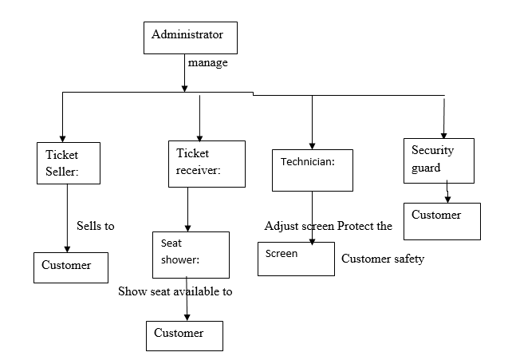

##### **Figure 2:1 Activity of existing system**

### **2.1.2 Problems in the existing system**

The existing system actually faces to a lot of problems, and these problems results due to the manual system of accomplishing its operations. Such as:

* **Ticket Reservation: -**In the cinema hall, there can be seen too many people standing in a long queues to buy movie ticket. This would make people tired while they need to stand in long times just to buy movie ticket. It is just wasting times and become unsatisfied.
* **Information related problems: -**because of the cinema use manual system the customers cannot easily acquire information about which movies are shown and the schedule**.** This means it is difficult to distribute the information to the customers.
* **Market related problems: -**most of the customers are local because of the system is not web based. Due to the manual system customers are limited with in local area.

**Efficiency**- due to the manual operation most of the activities are prone to wastage of resources like man power, time etc. to produce the corresponding outputs. This makes the existing system inefficient while utilizing resources.

### **2.1.3 Weakness and Strength**

**Weakness:**

Cannot be advertise properly the movie to customers.

Customer cannot use the time properly.

Their income is less due to number of employee.

**Strength**

The Reserved Tickets are not to be re-sold.

**Opportunities**

The interest of customer to watch movie increase from time to time.

**Threaten**

There may not be internet connection.

There may be electric power problem.

## **2.2** **Overview of the proposed system**

Our proposed system would be web based application and do the following activities:-

* First it announces movies on the website.
* Give movie schedule information for customers.
* Reserve seats for customers.
* Reserve ticket for customers.
* Customer can pay money online.
* Promote movies for the customers.

### **2.2.1 Functional requirement**

The functionality of the system use the following requirements:

Requirement 1. Delete/cancel Requirement 2.View seat information, announces, and feedback Requirement 3.Upload announce. Requirement4. Reserve, ticket.

Requirement 5.Update, announce and account.

Requirement 6.Add news, add new movie

Requirement 7.Register, stuff and customers.

Requirement 8.Announce movie.

Requirement 9. Announce movie schedule.

### **2.2.2 Non Functional Requirements**

**Security:**

* The system provide high level of security by blocking an unauthorised user to access secured system page by authenticating him
* The external security should be provided by giving login authentication.

**Performance:**

* Fast response time and optimal work environment.
* For login to the software password and user name should be processed with in short time with in short time.

**c**

* The end user able to access any page fast according to the internet connection speed.
* The User interface for this system is simple and clear.

**Availability**

* The availability of the software permits everyone who has an internet connection.
* The system is available for 24 hours and 7 days a week.

**Flexibility**

* The operation is flexible and can be presented in different ways.

**Maintainability**

* After the deployment of the project if any error occurs then it can be easily maintained by the software developer.

**Portability**

* The software work properly in any browsers and as well it is compatible with different operating system

**Robustness**

* If there is any error in any window or module then it should not affect the remaining part of the software

**Design Constraints:**

* The system would replace the existing system.

### **2.2.3 System Requirement**

**Hardware requirement**

* Client computer (desktop or laptop) with full accessories
* properly crimped network cable

**Software requirement**

* Web browser (Mozilla Firefox)

### **2.2.4 User Requirement**

To develop the system, the developer needs business to accomplish system on time. To develop the system we plan what requirement should be taken after planning the owner may take money loan from somewhere if they have no enough money before now. But they may not take loan, if they have money before now. The owner of the system should also assume how many end users use the system after the system completed to increase their business.

### **2.2.5 Business Rules in the Existing System**

A business rule is an effective operating principle or polices that we try to specify for both the existing system and the new system must satisfy. The business rule is a principle or a policy in which the proposed system operates accordingly. It deals with access control issues.

It often relates to access control issues, operating policies and principles of the organization. The organization has the following principles in the existing system which includes:

* **BR1**: The Reserved Tickets are not to be re-sold.
* **BR 2**: The management reserves the right to refuse entry.
* **BR 3:** Reserved Tickets are not return after selling.
* **BR 4:** There is no smoking in the cinema hall.
* **BR 5:** when the customer enter in to the cinema hall, the staff member check their ticket are reserved or not.
* **BR 6:** Food and drink are not allowed in the cinema hall.
* **BR 7:** shouting and disturbing others are not allowed.
* **BR 8:** Verbal and/or physical aggression towards staff would result in refusal of entry or requirement to leave.
* **BR 9:** Children must be accompanied by a responsible adult at all times

# 

# **CHAPTER THREE: SYSTEM MODELING**

# **3.1 use case model**

### **3.1.1 Actor specification**

#### **Table 3:1 actor specification**

|  |  |
| --- | --- |
| Actor name | Role |
| Administrator | who control and manage all the system what action is performed, and assign user account to registered users of the system, and manage the account of the user |
| Customer | Who reserve the ticket if he/she is a member of the bank and if he/she have money |
| Staff | Who add a movie time schedule and update/delete the movie and also the update their profile account. |

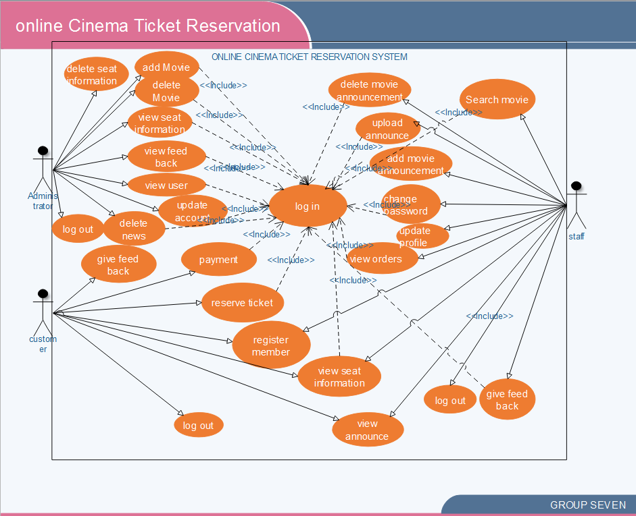 **Figure 3:1 Use case Diagram**

### **3.1.2 Use case description**

#### **Table 2:2 use case description for register**

|  |  |  |
| --- | --- | --- |
| Use case name: | Register | |
| Actor | customer | |
| Description | The system allow the user registered | |
| Precondition | The user who fulfill the criteria to registered | |
| Basic flow | User action | System response | |
| 1click registration button  3The user enter required information and Click register button. | 2. the system display registration form  4. validates the user information  5. The system informs the user that they successfully registered. | |
| Post condition: | The user would use the website | |
| Alternatives Flows: | If the user enters invalid password and username | |
|  | go back to step3 | 4.1The system display try again error message |

#### 

#### 

#### **Table 3:3 Login**

|  |  |  |
| --- | --- | --- |
| Use case name: | Login | |
| Actor | Staff, admin, customer | |
| Description | The system allow the staffs and the users to login to the system | |
| Precondition | The staffs and users must have user name and password to login | |
| Basic flow | User action | System response |
| 1.the staffs and users click login button  3. The staffs and users enter his/her username and password  4.Then click login button | 2. The system display login form  5. The system validates the entered information and display main page |
| Post condition: | The staff and users use their own pages | |
| Alternatives Flows: | If the staff enters invalid user name or password | |
| 6.2 Staffs and users reenter the correct information | 6.1 the system displays try again error message |

#### **Table 3:4 Upload announcement**

|  |  |  |
| --- | --- | --- |
| Use case name: | Upload announcement | |
| Actor | Staff | |
| Description | The system allow the staff to Upload announcement movie | |
| Precondition | The staff must login to the staff page | |
| Basic flow | User action | System response | |
| 1Click announcement link  3.the staff click Upload announcement button  5.The staff inserts and click upload button | 2.the system display announcement page  4. the system display announcement form  6. The system checks validity and display  7.End use case | |
| Post condition: | The staff can view the details Uploaded announcement movie | |
| Alternatives Flows: | If the staff inserts invalid information or not found | |
|  | 6.2 go back to step5 | 6.1 system display error message |

#### 

#### **Table 3:5 Update announcement movie**

|  |  |  |
| --- | --- | --- |
| Use case name: | Update announcement movie | |
| Actor | Staff | |
| Description | The system allow the staff to Update announcement movie | |
| Trigger |  | |
| Precondition | The staff must login to the admin page | |
| Basic flow | User action | System response | |
| 1.Click announcement link  3.the staff click update announcement button  5.The staff update required information  6. Then Click update button  8.End use case | 2.the system display the update announcement page  4. the system display announcement movie list  7. Validates entered information and informs the staff that they successfully updated. | |
| Post condition: | The announcement movie list would be up to date | |
| Alternatives Flows: | If the staff enters invalid information | |
|  | 6.2 Staff reenter the correct information again and add | 6.1The system display error message |

#### 

#### **Table 3:6 Add movie schedule**

|  |  |  |
| --- | --- | --- |
| Use case name: | Add movie schedule | |
| Actor | Staff | |
| Description | The system allow the staff to add movie and schedule | |
| Trigger |  | |
| Precondition | The staff must login to the staff page | |
| Basic flow | User action | System response | |
| 1.the staff click add movie and schedule button  3.The staff enter required information  4. Then Click add button | 2. the system display movie and schedule form  5. Validates entered information and informs the staff that they successfully added movie and schedule. | |
| Post condition: | The movie and schedule would be added to the list | |
| Alternatives Flows: | If the staff enters invalid information | |
|  | 6.2 Staff reenter the correct information again and add | 6.1The system display error message |

#### 

#### **Table 3:7 View seat information**

|  |  |  |  |
| --- | --- | --- | --- |
| Use case name | View seat information | | |
| Actor | customer and staff | | |
| Description | The system allow the customer and staffs to view seat information | | |
| Precondition | The customer and staff should have user name and password and must login to the system | | |
|  | User action | | System response |
| Basic flow | 1.the users click on view link  3.then click ”view” button | | 4.the system display the view form  5.the system would search the movie and schedule  6.the system would display the ticket number and time reserved |
| Post condition | The user can reserve a seat | | |
| Alternative flow | If there is error in the entry or no reserve found | | |
|  | 4.2 if nothing is found go to flow 1 | 4.1 if the message is gives error message | |

#### **Table 3:8 Reserve ticket**

|  |  |  |  |
| --- | --- | --- | --- |
| Use case name | Reserve | | |
| Actor | Customer | | |
| Description | The Customer to fill necessary information to the system | | |
| Precondition | The user should have account | | |
|  | User action | | System response |
| Basic flow | 1.for registration user would click the button “reserve”  3.the Customer fills all required information and click “submit” button | | 2. the system would display reservation form  4.the system checks the validity and availability  5.the system would display successfully message |
| Post condition | After collecting information from Customer, this Customers seat should be reserved | | |
| Alternative flow | If the Customers enters invalid information or if the seat is reserved | | |
| 4.2 go back to basic flow 1 | 4.1 the system gives error message | |

#### **Table 3:9 delete movie schedule**

|  |  |  |  |
| --- | --- | --- | --- |
| Use case name | delete movie schedule | | |
| Actor | Staff | | |
| Description | The system allow the user and staffs to delete movie schedule | | |
| Pre-condition | The user and staff should have user name and password and must login to the system | | |
|  | User action | System response | |
| Basic flow | 1.Click delete movie link  3.then click “delete schedule” button  5.the user fill the information and  6.select one and click “delete” button  9.End use case | 2.the system display delete movie page  4.the system would display delete form  7.the system would fetch and display schedule  8.the system would display successful message | |
| Post condition | The movie schedule would be deleted | | |
| Alternative flow | If the staff enters invalid information | | |
|  | 5.2. If nothing is found go to basic flow 3 | | 5.1.the system gives error message |

#### **Table 3:10 Update account**

|  |  |  |  |
| --- | --- | --- | --- |
| Use case name | Update account | | |
| Actor | Admin | | |
| Description | The system allow the user and staffs to update account | | |
| Pre-condition | The user and staff should have user name and password and must login to the system | | |
|  | User action | | System response |
| Basic flow | 1.Click update account link  3.then click “update account” button  5.the user fill the information and click “update” button  7.End use case | | 2.the system display update account page  4.the system would display update account form  6.the system would check the validity and display successful message |
| Post condition | The movie schedule would be added to the database. | | |
| Alternative flow | If the staff enters invalid information | | |
| 6.2 if nothing go back flow3 | 6.1the system give error message | |

**Table 3:11 View Feed back**

|  |  |  |
| --- | --- | --- |
| Use case name: | View Feed back | |
| Actor | Administrator | |
| Description | The system allow the admin to view and delete comments | |
| Precondition | The user must have admin user and password | |
| Basic flow | User action | System response | |
| 1.click “view comment” link  3. click view comment button  5. The admin fills required information and Click print button. | 2. the system display view comment page  4. the system display the available information  6. validates the user information  7. The system informs the admin that they successfully registered. | |
| Post condition: | System has successfully shown the comments | |
| Alternatives Flows: | If the admin enters invalid password and username | |
|  | 6.2 go back to step3 | 6.1The system display try again error message |

#### 

#### **Table 3:12 Logout**

|  |  |  |
| --- | --- | --- |
| Use case name | Logout | |
| Actor | Admin, Staff, user | |
| Description | The system allows the admin, staff and users to log out from the system | |
| Precondition | The staff and users must login | |
|  | User action | System response |
| Basic flow | 1.the staff clicks “logout” button | 2.the system display home page |

#### **Table 3:13 Payment**

|  |  |  |
| --- | --- | --- |
| Use case name: | Payment | |
| Actor | Customer | |
| Description | The system allow the user to pay money | |
| Precondition | The admin must have password and user name | |
| Basic flow | User action | System response | |
| 1.the user Click “payment” link  3.the users click payment button  6.End use case | 2.the system display the payment page  4. the system validates the password and user name  5. the system display successfully pied message | |
| : | If the use enters invalid information the system display try again message. | |

**3.2 Sequence Diagram** 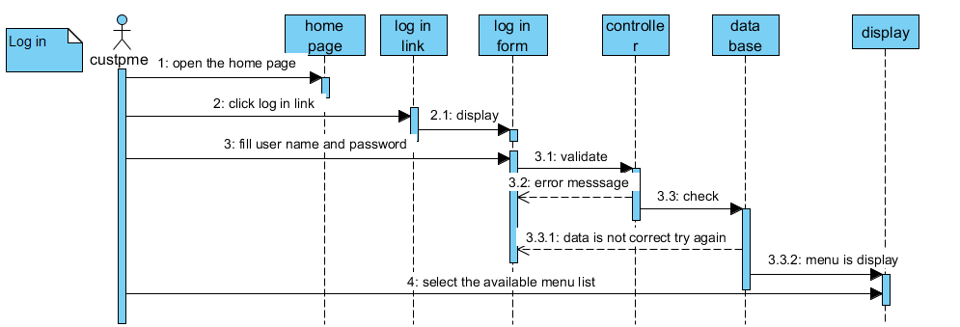

##### **Figure 2:2 login sequence diagram**

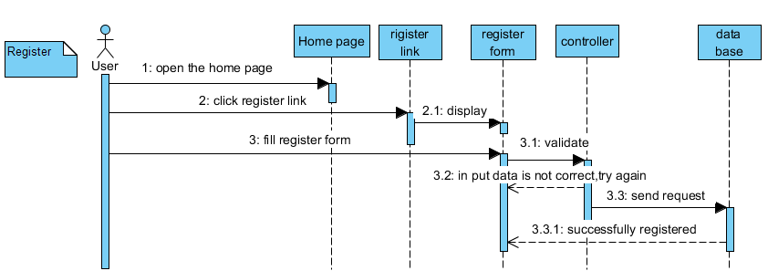 **Figure 3:3 Register sequence diagram**

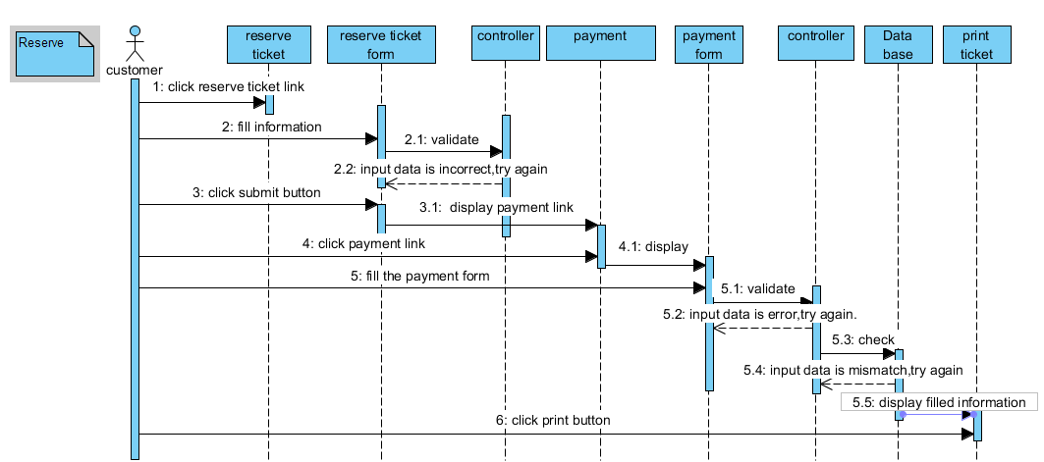

##### **Figure 3:4 reserve sequence diagram**

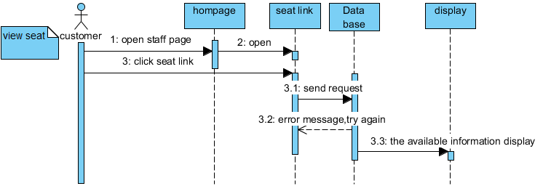

##### **Figure 3:5 View seat information sequence diagram**

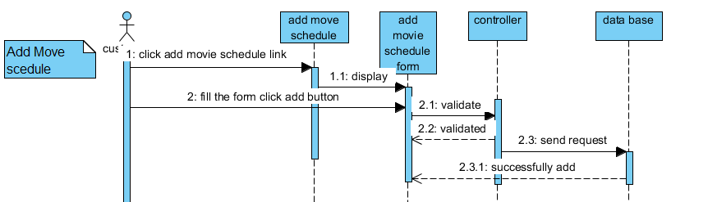

##### **Figure 3: 6 Add movie schedule sequence diagram**

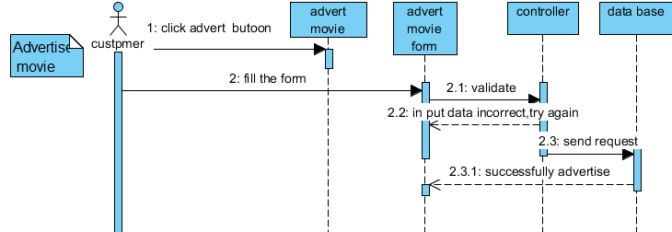 Figure 3:7 Advertise movie sequence diagram

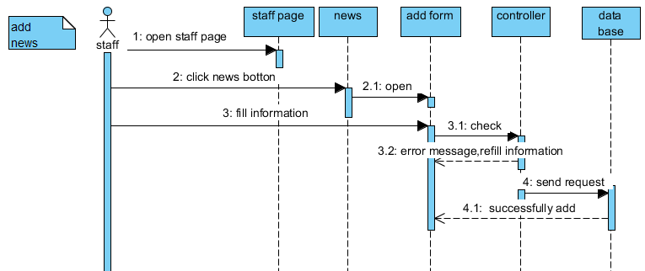 Figure 3:8 Add news sequence diagram 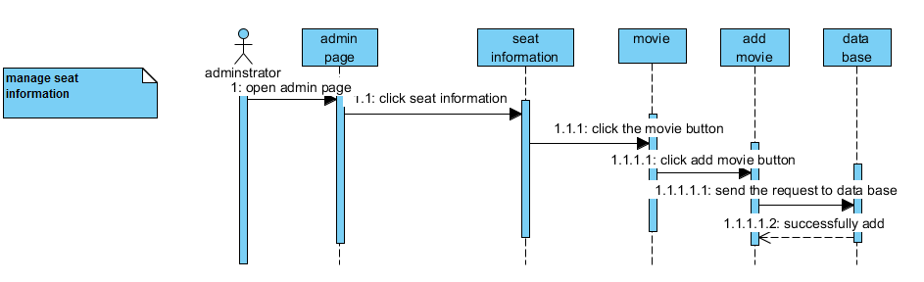Figure 3:9 manage add movie sequence diagram

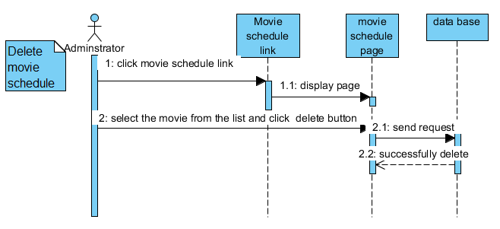**Figure 3:10 Delete movie schedule sequence diagram**

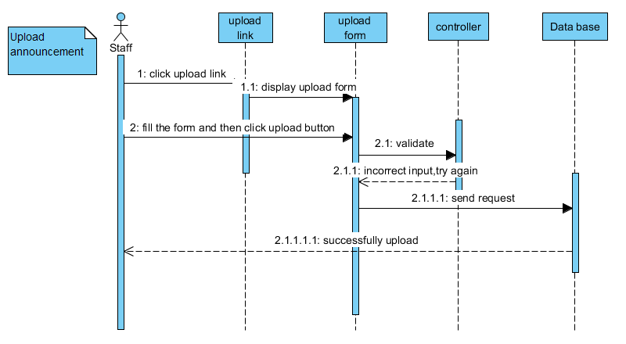**Figure 3:11 Upload announcement sequence diagram**

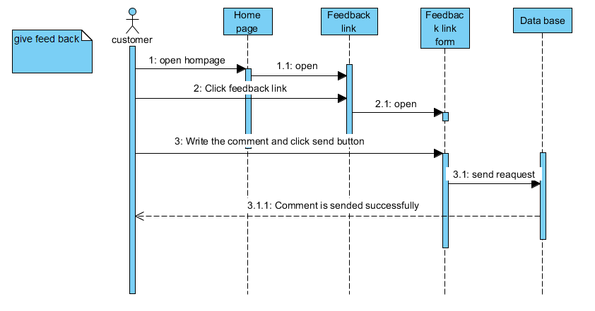

##### **Figure 3:12 Give feedback sequence diagram**

##### **3.3 class diagram**

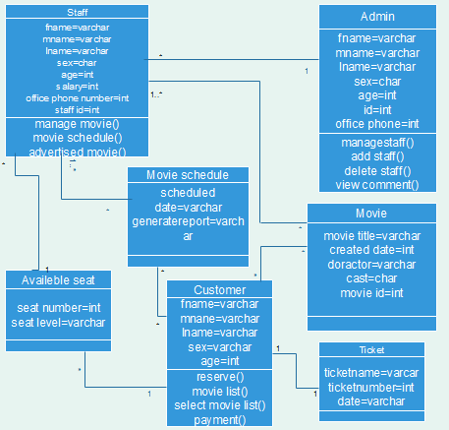

##### **Figure 3:13 Class diagram**

## **3.4 Activity Diagram**

An activity diagram illustrates the dynamic nature of a system by modeling the flow of control from activity to activity.

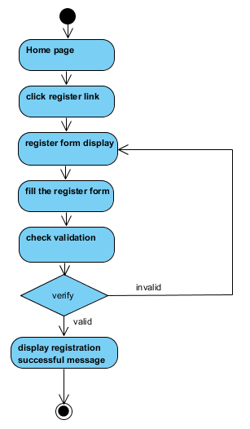

##### **Figure 3:14 Register activity diagram**

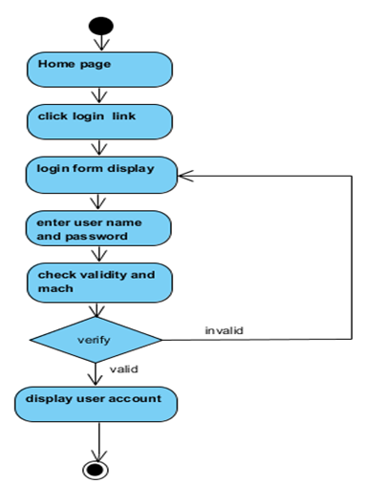

##### **Figure 3:15 Log in activity diagram**



##### **Figure 3:16 Reserve ticket activity diagram**

**Figure 3:17 View seat information activity diagram**

##### **Figure 3:18 Advert movie activity diagram**

# **CHAPTER FOUR: SYSTEM DESIGN**

# 

## **4.1 Design Goal**

The goal of the system design is to manage complexity by dividing the system in to manageable pieces. Some of the goals are listed below.

* **Security**: The system is secured from unauthorized user by asking user name and password and check the input information that is matched or not.
* **Modifiability**: The system is modifiability to modify different services depending on the need of the institute.
* **Flexibility:** The system able to change to suit new condition or situation.
* **Efficiency:** The system can do what it is supposed to do efficiently without the problem, process with in short period of time.

## **4.2 System Decomposition**

In order to simplify and minimize the complexity of the solution domain, our system has been divided into four subsystems based on their functionality. These are reserving subsystem, registering Subsystem and Administration subsystems. The decomposition of the system is represented in the Figure below.

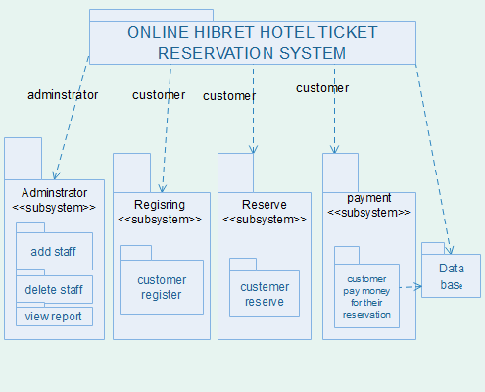

##### **Figure 4:1 System decomposition**

## **4.3 System architecture design**

A software system is a set of communicating entities that collaborate to perform a task. The Architectural Design is a top level design which shows these entities, their relationships.

**Figure 4:2 Architectural diagram of the system**

## **4.4 Deployment Diagram**

Deployment diagram shows physical communication links between hardware items. And relationship between physical machine and processes.

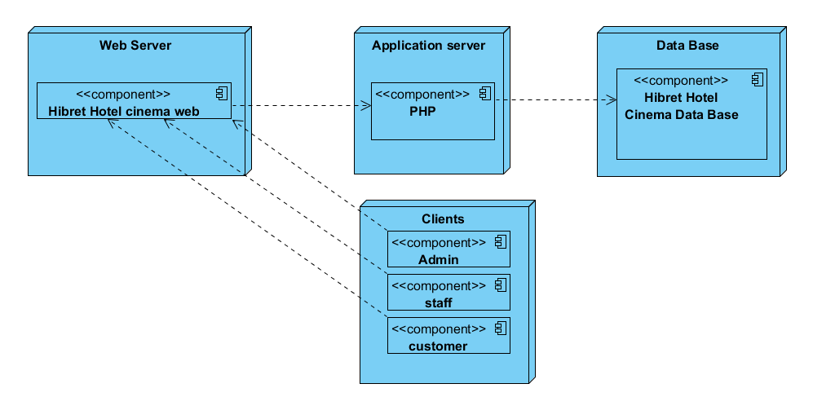Figure 4:3 Deployment diagram

## 

## **4.5 Persistence Data Management**

Persistent data management deals with how persistent data (file, database) are stored and managed.

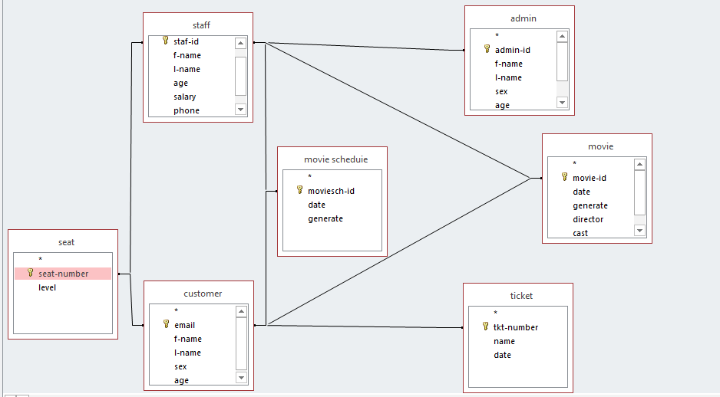**Figure 4:4 Persistence data management diagram**

## **4.6 Access control and security**

Access control and security specifies what the user can access or what cannot perform by some users. In the system, different actors have access to different information and data.

#### **Table 4:1 access control and security**

|  |  |
| --- | --- |
| Actors | Privilege/permission to do |
| Customer | * View the cinema information detail. * Log in to the reservation page. * Reserve ticket. * View movies time schedule. * View seat information * View Announcement * Register * Pay the money for reserving * Give feedback |
| Staff | * Log in to the system. * Add/ remove movie schedule information in the site. * Add/delete news * View seat information * Give feedback |
| Manager | * Control entire activity in the site. |

### 

## 

## **4.7 User Interface Design**

Describe the logical characteristics of each interface between the software product and the users.

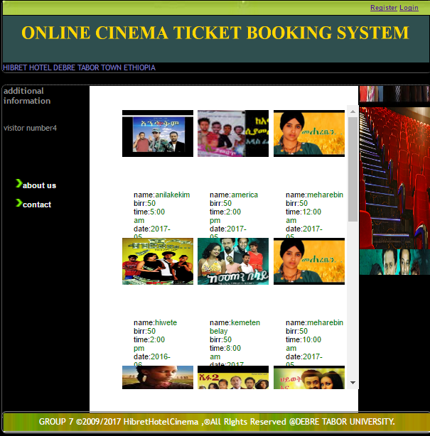

##### Figure 4:5 Home page interface

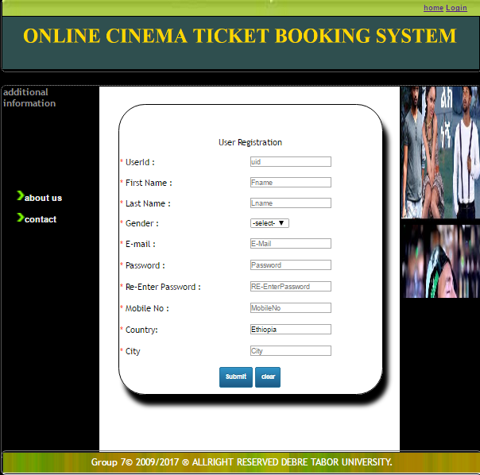

##### **Figure 4:6 Registration form**

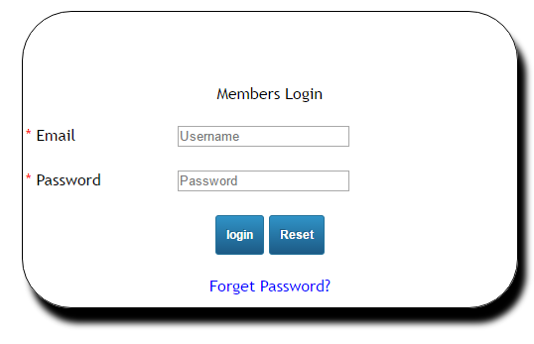

##### **Figure 4:7 log in form**

# 

# **CHAPTER FIVE: IMPLEMENTATION**

Implementation refers to the Coding of the all documents gathered starting from requirement analysis to Design phase. So now the team is in a position of converting all documents gathered and designed into the code so that the system would be implemented for the user to be used for the purpose it developed.

In the implementation phase all the programs are written, database is created, user operational document is written, and the system tested with operational data. The implementation is carried out with the results that have been obtained from the feasibility study and analysis. The system is implemented by finishing the project with the help of appropriate tools that have been suggested and loaded in to the server. Then the system is tested with appropriate data inputs to check the successfulness of the system. Which means that we test our system modules based on unit test. After that we check integration test and finally we checked system or acceptance test of our system.

**5.1 Tools**

We use the following tools to develop our system:-

**Soft ware**

* We use Dreamweaver tool to design the web pages.
* We use MySQL database system,
* We use Wamp server,
* We use Mozilla Firefox,
* Google chrome,
* Spark Window10.
* We use Programming languages*: - PHP, MSQL, JavaScript, CSS, and HTML.*

**Hard Ware**

* RAM(Random access memory),
* HDD(hard disk drive),
* Core i3 processor ,
* monitor ,
* USB flash disk,
* CD.

## **5.2 Algorithm**

We use Pseudo code algorithm which is compact and informal high-level description of a computer programming algorithm that uses the structural conventions of a programming language but is intended for human reading rather than machine reading. Pseudo code typically omits details that are not essential for human understanding of the algorithm, such as variable declaration. The programming language is augmented with natural language descriptions of the details, where convenient, or with compact mathematical notation. The purpose of using pseudo code is that it is easier for humans to understand than conventional programming language code, and that it is a compact and environment-independent description of the key principles of an algorithm.

**Algorithms for displaying admin page**

Click login link then,

Display login form,

Fill user name and password and press submit button,

If the filled data is valid display the admin page of the actor.

Else

Display error message and return back to the login page,

Refill the form, Display admin page,

End.

**Algorithms for displaying customer registration**

Click registration link then,

Display the registration form.

Fill user id, first name, last name, gender, email, password, re-enter password, mobile number, country, city and press submit button.

If the filled input is valid,

Display member login page.

Else

Display error message.

Re-fill again.

Display member login page.

End.

## **5.3 Environments**

The environment is very restrictive for implementing this system as well using it. When we say this it is impossible to access this system out of coverage of network access mean that it is connection dependent. Since our system is web based; it is allowed on all operating system, and all electronic devices that are capable to access web.

**5.4 Sample code and sample output sample code of advert**

<?php include("includes/db.php"); ?> <html>

<head>

<script type="text/javascript" src="jquery.js"></script>

<script type="text/javascript" src="mhgallery.js"></script>

<script type="text/javascript" src="initgallery.js"></script>

<link type="text/css" rel="stylesheet" href="mhgallery.css" />

<title>Online ticket booking system for Hibret Hotel cinema</title>

<link rel="stylesheet" href="css/style.css" type="text/css" media="all" />

<style>

</style>

</head> <body bgcolor="black">

<table width="910" id="table1" align=center style="border-bottom:1px solid #f6b45f;margin-top:1%; border:1px dotted #aaaaaa; ">

<tr>

<td align="center" id="heder" width=900 height=30 ><p align=right style="margin-right:3%;">

<a href="singup.php" title="Register">Register</a>

<a href="login.php" title="Login">Login</a>

<a href="http://www.facebook.com" target=_blank ><img src="images/facebook.png"/></a>

<a href="http://www.twitter.com" target="_blank"><img src="images/twitter.png"/></a>

<a href="http://www.google.com" target="_blank"><img src="images/google.png"/></a></p>

</td>

</tr>

<tr>

<td >

<img src="image/11.PNG" width=920 height=100>

</td>

</tr>

<tr>

<td align="center" id="heder" width=900 height=30 ><p align=right style="margin-right:3%;">

<div id="mhgallery">

<style type="text/css">

#mhgallery img { display:none; }

</style>

<center><img src="image11/51.jpg"/>

<img src="image11/52.jpg"/>

<img src="image11/53.jpg"/>

<img src="image11/54.jpg"/>

<img src="image11/ayrak.jpg"/>

<img src="image11/56.jpg"/>

<img src="image11/57.jpg"/>

<img src="image11/58.jpg"/>

<img src="image11/abat.jpg"/>

<img src="image11/59.jpg"/>

<img src="image11/62.jpg"/>

<img src="image11/65.jpg"/>

<img src="image11/67.jpg"/>

<img src="image11/58.jpg"/>

<img src="image11/59.jpg"/>

<img src="image11/12.jpg"/>

<img src="image11/hall1.jpg"/>

</center>

</div>

</td>

</tr>

</table>

<table width="910" id="table1" align="center" style="border-bottom:1px solid #f6b45f;margin-top:0.5%; border:1px dotted #aaaaaa;margin-top:1%;">

<tr>

<td valign="top" height="100" width="180" id="menu-bar" id="table2" >

<h2><big ><font size=4> additional information</font></big></h2><br>

<a href="contact.php"><img src="images1/widget-arrow.png" width="15" />Contact Us</a>

<a href="aboutus.php"><img src="images1/widget-arrow.png" width="15" />AboutUs</a>

</td>

</div>

</td>

<td valign="top" id="idd" style=" background-color:white;">>

<div align="center">

<h3 ><font color=white>amharic movie</h3>

<div class="view1">

<table>

<tr>

<td><img src="image11/engineer.jpg" width="200" height="100"></td>

<td>

<img src="image11/53.jpg" width="200" height="100"></td>

<td>

<img src="image11/52.jpg" width="200" height="100">

</td>

<td><img src="image11/51.jpg" width="200" height="100"></td></tr>

<tr>

<td><img src="image11/57.jpg" width="200" height="100"></td>

<td>

<img src="image11/54.jpg" width="200" height="100"></td>

<td>

<img src="image11/55.jpg" width="200" height="100">

</td>

<td><img src="image11/56.jpg" width="200" height="100"></td></tr>

<tr>

<td><img src="image11/50.jpg" width="200" height="100"></td>

<td>

<img src="image11/67.jpg" width="200" height="100"></td>

<td>

<img src="image11/60.jpg" width="200" height="100">

</td>

<td><img src="image11/53.jpg" width="200" height="100"></td></tr>

<tr>

<td><img src="image11/62.jpg" width="200" height="100"></td>

<td>

<img src="image11/183b_d99a.jpg" width="200" height="100"></td>

<td>

<img src="image11/207d_9e30.jpg" width="200" height="100">

</td>

<td><img src="image11/66.jpg" width="200" height="100"></td></tr>

</table>

</div>

</div>

</td>

<td valign="top" height="700" width="150" id="td2" >

<h2><p valign=top>Advertise</h3></p><a href="http://">

<marquee direction=up align=middle height=500px scrollamount=3 style="background:url('images/Habesha1.gif');height:400;">

<img src="image11/58.jpg" alt="" width=150 height=300/>

<img src="image11/02.jpg" alt="" width=150 height=300/>

<img src="image11/01.jpg" alt="" width=150 height=300/>

<img src="image11/57.jpg" alt="" width=150 height=300/>

<img src="image11/59.jpg" alt="" width=150 height=300/>

<img src="image11/62.jpg" alt="" width=150 height=300/>

</marquee>

</td>

</tr>

<tr>

</tr>

</table>

<table width=910 border=1 align="center" cellpadding="0px" id="table2">

<tr>

<td style="background:url('images1/background.png');" width=910 height=40 >

<font color=white size=4px ><p align=center>GROUP 7,&copy;2009/2017, HibretHotelCinema.&reg; All RIghts Reserved<br>

</p>

</td>

</tr>

</table>

</body>

</html>

**SAMPLE CODE OF LOGIN**

<?php

include("includes/db.php");

//Start session

session_start();

//Unset the variables stored in session

unset($_SESSION['SESS_MEMBER_ID']);

unset($_SESSION['SESS_FIRST_NAME']);

function createRandomPassword() {

$chars = "abcdefghijkmnopqrstuvwxyzABCDEFGHIJKLMNOPQRSTUVWXYZ0123456789";

srand((double)microtime()*1000000);

$i = 0;

$pass = '' ;

while ($i <= 3) {

$num = rand() % 33;

$tmp = substr($chars, $num, 1);

$pass = $pass . $tmp;

$i++;

}

return $pass;

}

$confirmation = createRandomPassword();

?>

<!DOCTYPE html PUBLIC "-//W3C//DTD XHTML 1.0 Transitional//EN" "http://www.w3.org/TR/xhtml1/DTD/xhtml1-transitional.dtd">

<html xmlns="http://www.w3.org/1999/xhtml">

<head><title>Online ticket booking system for Hibret Hotel</title>

<link rel="stylesheet" href="css/style.css" type="text/css" media="all" />

<style>

a{

color:black;

text-decoration:none;

}

</style>

<script type="text/javascript">

if (document.images) { // Preloaded images

}

function timeimgs(numb) { // Reusable timer

thetimer = setTimeout("imgturn('" +numb+ "')", 7000);

}

function imgturn(numb) { // Reusable image turner

if (document.images) {

if (numb == "5") { // This would loop the image

document["demo"].src = eval("demo5.src");

timeimgs('1');

}else {

document["demo"].src = eval("demo" + numb + ".src");

timeimgs(numb = ++numb);

}

}

}

</script>

</head>

<body bgcolor="black">

<table width="910" id="table1" align=center style="border-bottom:1px solid #f6b45f;margin-top:1%; border:1px dotted #aaaaaa;">

<tr>

<td align="center" id="heder" width=900 height=30 ><p align=right style="margin-right:3%;">

<span><a href="singup.php" title="Register">Register</a>

<a href="\cinema ticket\index.php" title="Login">home</a>

</td>

</tr>

<tr>

<td >

<img src="image/11.PNG" width=900 height=200>

<span class="style5">HIBRET HOTEL DEBRE TABOR TOWN ETHIOPIA</span></td>

</td>

</tr>

<tr>

<td >

<div id="topnav" >

<div class="shell">

<ul>

</li>

</ul>

<div class="cl">&nbsp;</div>

</div>

</div>

</li>

</ul>

</li>

</ul>

<div class="cl">&nbsp;</div>

</div>

</div>

</td>

</tr>

<tr>

<td align="center" >

<table width="910" id="table1" align="center" style="border-bottom:1px solid #f6b45f;margin-top:0.5%; border:1px dotted #aaaaaa;margin-top:1%;">

<tr>

<td valign="top" height="500" width="180" id="menu-bar" id="table2" >

<h2><big style="color:geern" >Information</big></h2><br><br>

<a href="aboutus.php"><img src="images1/widget-arrow.png" width="15" />about us</a>

<a href="contact.php"><img src="images1/widget-arrow.png" width="15" />contact</a>

<a href="english.php"><img src="images1/widget-arrow.png" width="15" />english advert</a>

<a href="amharic.php"><img src="images1/widget-arrow.png" width="15" />amharic advert</a>

</td>

</div>

</td>

<td valign="top" id="tad" style=" background-color:white;">

<form name="form1">

<input type="hidden" name="productid" />

<input type="hidden" name="command" />

</form>

<div align="center">

<!-------------- -->

<table border=0 width="500" >

<tr>

<td>

<script type='text/javascript'>

function formValidation(){

//assign the fields

var txt_username = document.getElementById('txt_username');

if(emailValidator(txt_username,"check your e-mail format")){

return true;

}

return false;

}

function emailValidator(elem, helperMsg){

var emailExp = /^[\w\-\.\+]+\@[a-zA-Z0-9\.\-]+\.[a-zA-z0-9]{2,4}$/;

if(elem.value.match(emailExp)){

return true;

}else{

alert(helperMsg);

elem.focus();

return false;

}

}

</script>

<form action="login.php" method="post" onsubmit='return formValidation()'>

<table style="border:1px solid black; border-radius:50px;margin-top:15px;box-shadow:8px 15px 8px black;" width="500px" height="300px" align="center">

<tr><td colspan=2 align=right><font color=black><p style="margin-right:3%;"></td></tr><tr>

<tr>

<td colspan=2 align=center><font color=black>Members Login </td>

</tr>

<tr>

<td><font color=red> * </font><font color=black>Email</td><td><input type="text" name="mail" required x-moz-errormessage="" title="Enter the Email" value="" size="20%" id="txt_username" placeholder="Username"></input></td></tr>

<tr>

<td><font color=red> * </font><font color=black>Password</td><td><input type="password" name="pass" required x-moz-errormessage="Please enter the Password" title="Enter the Password" value="" size="20%" id="txt_password" placeholder="Password"></input></td></tr>

<tr>

<td colspan=2 align=center><input type='submit' class="button_example" value='login' name='submitMain' Onclick="return check(this.form);"/>

<input type='reset' class="button_example" value='Reset'/></td></tr>

<tr>

<td colspan=2 align=center><a href="forget.php"><font color=blue>Forget Password?</a></td></tr>

</form>

<!--Php Script-->

<?php

if(isset($_POST['submitMain']))

{

$user =$_POST['mail'];

$_SESSION['mail']=$_POST['mail'];

$password=$_POST['pass'];

$query = "SELECT * FROM user WHERE email= '{$user}' AND password= '{$password}';";

$result = mysql_query($query);

// TO check that at least one row was returned

$rowCheck = mysql_num_rows($result);

$row=mysql_fetch_array($result);

if($row['status']==1){

$_SESSION['SESS_MEMBER_ID']=$confirmation;

echo "<script>window.location='../cinema ticket/admin/product.php';</script>";

}

else if($row['status']==2){

$_SESSION['SESS_MEMBER_ID']=$confirmation;

echo "<script>window.location='../cinema ticket/admin/manager/add_news.php';</script>";

}

else if($row['status']==4){

$_SESSION['SESS_MEMBER_ID']=$_POST['mail'];

echo "<script>window.location='/cinema ticket/customer/veiwseat.php';</script>";

}

else {

echo"<p class='wrong'>User Name & Password Not Match !!</p>";

echo'<meta content="5;login.php" http-equiv="refresh" />';

}

}mysql_close($conn);

?>

</fieldset>

</table>

</table>

</div>

</div>

</td>

<<td valign="top" height="700" width="150” id="td2" >

<marquee direction=down align=middle height=500px scroll amount=3 style="background:url('img/main/blue.jpg');height:400;">

<img src="image11/60.jpg" alt="" width=150 height=300/>

<img src="image11/12.jpg" alt="" width=150 height=300/>

<img src="image11/14.jpg" alt="" width=150 height=300/>

<img src="image11/50.jpg" alt="" width=150 height=300/>

<img src="image11/12.jpg" alt="" width=150 height=300/>

<img src="image11/428355_422367841176516_92060453_n.jpg" alt="" width=150 height=300/>

</marquee>

</td>

</tr>

<tr>

</tr>

</table>

<table width=910 border=1 align="center" cellpadding="0px" id="table2">

<tr>

<td style="background:url('images1/background.png');" width=900 height=40 >

<font color=white size=4px ><p align=center>Group 7&copy; 2009/2017 &reg;RIGHT RESERVED.</p>

</td>

</tr>

</table>

</body>

</html>



Figure 5:1 Sample output of home page



##### **Figure 5:2 Sample output of login**

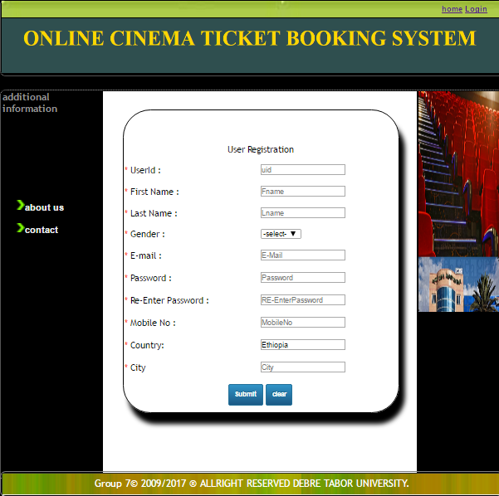

##### **Figure 5:3 Sample output of user registration**

# 

# **CHAPTER SIX: TESTING**

## **6.1 Unit testing**

Every module of the System is separately tested. That is the team tests every module by applying some selection mechanism. Through this mechanism every modules gets tested. If an error occurs correction would be taken without affecting another module. We have tried to test user interface screens of our system that needs to verify screen elements that appears on the screen.

In this type of testing, components are test individually. In case of our system, all components would test to maximum satisfaction. The components that would be test are:-

* Register customer and staff,
* Reserve ticket,
* Delete and upload the information,
* Display how many customers get the service.

## **6.2 Integration Testing**

In this testing part, all the modules would be combined together and tested, for its fitness with each other and with the systems functionality. Errors in our integration test are fix and the module with problem would be identified, solved and recombined. As a number of components are complete, we would test to ensure that they integrate well with each other and compatible with the operating system, and also other components.

## **6.3 System testing**

Here we compile the whole system starting from initial and proceed testing the whole system to check out for the errors and flow control of the system. In this testing approach our team considers how the whole sub system of Hibret Hotel Cinema work together to achieve goals of our project. Its goals are to detect faults like function validations, performance and security of Hibret Hotel Cinema.

In general we check the following concepts

1. Evaluate the functionality of subsystem after combination of individual subsystem weather it works correctly or not.
2. Check the overall functionality of Hibret Hotel Cinema that achieves the customer requirement.
3. Measure the system boundary which is beyond the goal or not.
4. Measure the weakness and the strength of the system using different metrics.
5. Check the interaction of each subsystem that performs the specified task.

### **6.3.1 Alpha testing**

Alpha testing is a type of acceptance testing performed to identify all possible issues/bugs before releasing the product to everyday user or public. Our group members test the system after completed it.

### **6.3.2 Beta testing**

Our group members would get feedback from end users, and this feedback would be important to redesign our system.

# **CHAPTER SEVEN: CONCLUSION AND RECOMMENDATION**

## **7.1 Conclusion**

The software that we developed would benefit for Hibiret cinema which is found in South Gonder. For the owner of organization the changing of existing system into computerized system would minimize the number of employees and provide flexible service to user this makes the organization profitable and as well as they can easily announce their service to customer to increase their customer in number . On the other hand it saves customer’s time and money as they can reserve ticket online.

In general, the benefits of our system can be summarized as improved manual system and safety customer’s service by making computerized and online ticket reservation.

## **7.2 Recommendation**

The system that we have tried to automate is not the whole system of the online cinema ticket reservation system. Because of time limitation and budget, we can’t develop all parts of the system, but we tried to automate most of sub systems and functionalities.

The following functionalities can’t be automated because of the limitations that we have discussed above.

* Ticket cancelation impossible.
* The system support only English language.
* Receipt of payment and receipt of seat reservation are not generated in one paper.
* Automatic generation of seats number during reservation is not possible

**Therefore, others interested individuals to develop on online cinema Ticket reservation can get some initial idea about the system and no need of more data gathering process the only need would be improving the system.**

**Reference**

1. <http://www.ethiobusinessmap.com/CinemasandTheatures.php?cinemahallID=3>
2. <https://www.google.com.et/?gws_rd=cr&ei=macIU8zIDcaSswa9_4DYCw#q=cinema%20ras>
3. [http://www.atgtickets.com/ venues/ambassadors-cinemas/](http://www.atgtickets.com/%20%20venues/ambassadors-cinemas/)
4. <http://www.scribd.com/doc/80258611/Online-Ticket-Reservation-System-for-Cinema-Hall>
5. <http://seminarprojects.com/Thread-project-on-online-movie-booking-system>

## 

## **Appendix**

**Questionnaires** 1.When the cinema was established?

2. How many seats are available in the cinema hall?

3. How many employee work in the cinema?

4. How many birr payed for one ticket?

5. What is the responsibility of administrator?

6. During movies are watch on progress, if the power is off what solution do you take?

7. How many birr payed for one employee per month?

8. What is the resolution of screen you use in the cinema?

9. is there any fixed day in which the movie are seen?

10. How do you work currently?

11. What is the problem of current system?